Q2: CPU Scheduling
Problem context: Cloud Video-Encoding Service | 8 Marks | Bloom’s Level K5 – Evaluate

1. Job Set and Assumptions
The same set of jobs from the TODO program is used for every algorithm, so the results are comparable.
Process | Arrival time | Burst time | Priority (1 = highest)
P1 | 0 | 8 | 2
P2 | 1 | 4 | 3
P3 | 2 | 9 | 1
P4 | 3 | 5 | 4

- Priorities: The question gives no priorities, so I assumed the values above. They are my own assumption and can be changed.
- Variants: Priority scheduling is non-preemptive. SJF is non-preemptive and SRTF is its preemptive version. Round Robin uses a quantum of 3 unless stated.
- Formulas: Turnaround time (TAT) = finish − arrival. Waiting time (WT) = TAT − burst. Response time (RT) = first CPU time − arrival.
- Overhead: Context-switch time itself is taken as zero; switches are only counted.

2. Gantt Charts
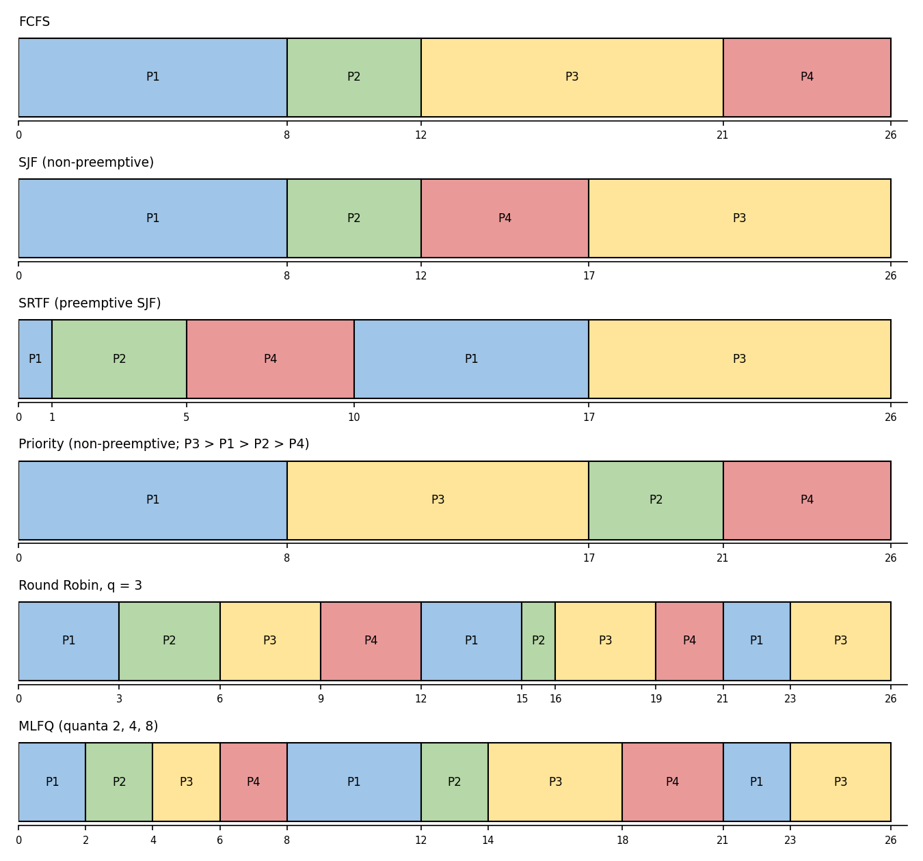

3. Calculations per Algorithm

3.1 FCFS
Gantt: P1(0-8) P2(8-12) P3(12-21) P4(21-26)
Process | Finish | TAT | WT | RT
P1 | 8 | 8 | 0 | 0
P2 | 12 | 11 | 7 | 7
P3 | 21 | 19 | 10 | 10
P4 | 26 | 23 | 18 | 18
Average |  | 15.25 | 8.75 | 8.75

3.2 SJF (non-preemptive)
Gantt: P1(0-8) P2(8-12) P4(12-17) P3(17-26)
Process | Finish | TAT | WT | RT
P1 | 8 | 8 | 0 | 0
P2 | 12 | 11 | 7 | 7
P3 | 26 | 24 | 15 | 15
P4 | 17 | 14 | 9 | 9
Average |  | 14.25 | 7.75 | 7.75

3.3 SRTF (preemptive SJF)
Gantt: P1(0-1) P2(1-5) P4(5-10) P1(10-17) P3(17-26)
Process | Finish | TAT | WT | RT
P1 | 17 | 17 | 9 | 0
P2 | 5 | 4 | 0 | 0
P3 | 26 | 24 | 15 | 15
P4 | 10 | 7 | 2 | 2
Average |  | 13.00 | 6.50 | 4.25

At time 1, P2 (burst 4) is shorter than P1’s remaining 7, so P1 is preempted. At time 3 P4 arrives, but P2’s remaining 2 is still smaller. At time 5, P4 (5) beats P1 (7) and P3 (9).

3.4 Priority (non-preemptive)
Gantt: P1(0-8) P3(8-17) P2(17-21) P4(21-26)
Process | Finish | TAT | WT | RT
P1 | 8 | 8 | 0 | 0
P2 | 21 | 20 | 16 | 16
P3 | 17 | 15 | 6 | 6
P4 | 26 | 23 | 18 | 18
Average |  | 16.50 | 10.00 | 10.00

P1 starts alone at time 0 and cannot be preempted. At time 8, P3 (priority 1) runs first, then P2 (priority 3), then P4 (priority 4).

3.5 Round Robin (quantum 3)
Gantt: P1(0-3) P2(3-6) P3(6-9) P4(9-12) P1(12-15) P2(15-16) P3(16-19) P4(19-21) P1(21-23) P3(23-26)
Process | Finish | TAT | WT | RT
P1 | 23 | 23 | 15 | 0
P2 | 16 | 15 | 11 | 2
P3 | 26 | 24 | 15 | 4
P4 | 21 | 18 | 13 | 6
Average |  | 20.00 | 13.50 | 3.00

3.6 Summary
Algorithm | Avg TAT | Avg WT | Avg RT | Finish time
FCFS | 15.25 | 8.75 | 8.75 | 26
SJF | 14.25 | 7.75 | 7.75 | 26
SRTF | 13.00 | 6.50 | 4.25 | 26
Priority | 16.50 | 10.00 | 10.00 | 26
Round Robin (q=3) | 20.00 | 13.50 | 3.00 | 26

Every algorithm finishes at time 26 because the CPU is never idle, so processor utilisation is the same (100%) for all of them. The algorithms differ only in who waits.

4. Round Robin Program (TODO 1 Completed)
The program below fills in TODO 1. I also added response time, a context-switch counter and a command-line argument for the quantum (default 3) so the quantum study can be run without recompiling.
#include <stdio.h>
#include <stdlib.h>
#define N 4

int main(int argc, char **argv) {
const char *name[N] = {"P1", "P2", "P3", "P4"};
int arrival[N] = {0, 1, 2, 3};
int burst[N] = {8, 4, 9, 5};
int quantum = (argc > 1) ? atoi(argv[1]) : 3;

int left[N], finish[N], start[N], queue[256], head = 0, tail = 0, added[N] = {0};
for (int i = 0; i < N; i++) { left[i] = burst[i]; start[i] = -1; }
int time = 0, done = 0, switches = 0, last = -1;
queue[tail++] = 0;
added[0] = 1;
printf("Gantt:");
while (done < N) {
int p = queue[head++];
/* TODO 1 completed */
int run = left[p] < quantum ? left[p] : quantum;
if (start[p] < 0) start[p] = time;
if (last != -1 && last != p) switches++;
printf(" %s(%d-%d)", name[p], time, time + run);
time += run;
left[p] -= run;
last = p;
for (int i = 0; i < N; i++) /* admit new arrivals first */
if (!added[i] && arrival[i] <= time) { queue[tail++] = i; added[i] = 1; }
if (left[p] > 0) queue[tail++] = p; /* then requeue p at the end */
else { finish[p] = time; done++; }
}
double tw = 0, tt = 0, tr = 0;
printf("\nProcess TAT WT RT\n");
for (int i = 0; i < N; i++) {
int tat = finish[i] - arrival[i], wt = tat - burst[i], rt = start[i] - arrival[i];
tt += tat; tw += wt; tr += rt;
printf("%-7s %4d %3d %3d\n", name[i], tat, wt, rt);
}
printf("Average TAT = %.2f, average WT = %.2f, average RT = %.2f\n", tt/N, tw/N, tr/N);
printf("Context switches = %d\n", switches);
return 0;
}

The order matters: new arrivals are added to the queue before the preempted process goes back, which is what the TODO asks for and what produces the expected Gantt chart.

Output with quantum 3 (matches the expected output)
Gantt: P1(0-3) P2(3-6) P3(6-9) P4(9-12) P1(12-15) P2(15-16) P3(16-19) P4(19-21) P1(21-23) P3(23-26)
Process TAT WT RT
P1 23 15 0
P2 15 11 2
P3 24 15 4
P4 18 13 6
Average TAT = 20.00, average WT = 13.50, average RT = 3.00
Context switches = 9
The TAT, WT and the averages (20.00 and 13.50) match the expected output exactly. The Gantt chart also matches.

5. Evaluation of the Time Quantum
The program was run with quantum 1, 3, 5 and 20 (./rr 1, ./rr 3, and so on). Context switches count only changes from one process to a different one.
Quantum | Avg TAT | Avg WT | Avg RT | Context switches | Gantt slices
1 | 19.00 | 12.50 | 0.75 | 23 | 26
3 | 20.00 | 13.50 | 3.00 | 9 | 10
5 | 17.50 | 11.00 | 5.50 | 5 | 6
20 | 15.25 | 8.75 | 8.75 | 3 | 4

Quantum 1 output
Gantt: P1(0-1) P2(1-2) P1(2-3) P3(3-4) P2(4-5) P4(5-6) P1(6-7) P3(7-8) P2(8-9) P4(9-10) P1(10-11)
P3(11-12) P2(12-13) P4(13-14) P1(14-15) P3(15-16) P4(16-17) P1(17-18) P3(18-19) P4(19-20)
P1(20-21) P3(21-22) P1(22-23) P3(23-24) P3(24-25) P3(25-26)
Average TAT = 19.00, average WT = 12.50, average RT = 0.75 Context switches = 23

Quantum 20 output
Gantt: P1(0-8) P2(8-12) P3(12-21) P4(21-26)
Average TAT = 15.25, average WT = 8.75, average RT = 8.75 Context switches = 3

What the study shows
- Small quantum: best response, most switches. With quantum 1, every job gets the CPU almost immediately (average response 0.75), but there are 23 context switches. In a real server each switch costs time, so a very small quantum wastes CPU on switching.
- Large quantum: degenerates into FCFS. With quantum 20, every job finishes in one go, so Round Robin behaves exactly like FCFS (same Gantt, 8.75 average waiting time). Response time is the worst here (8.75), and a short job waits behind a long one, which is the customers’ complaint.
- Trade-off: Average waiting time falls as the quantum grows in this data set (12.5 → 13.5 → 11.0 → 8.75). The 1 → 3 step goes slightly the other way because P2’s early finish at quantum 1 helps the average. In general, waiting time is not monotonic in the quantum, so the trend here should not be treated as a rule.
- Good choice: The quantum should be larger than the context-switch time, and large enough that most short jobs finish within one or two quanta, but small enough to keep response time low. A common rule of thumb is that about 80% of CPU bursts should be shorter than the quantum.

6. Starvation and Ageing
- SJF / SRTF: SJF and SRTF always pick the shortest job. If short jobs keep arriving (thumbnails every second), a 20-minute film may never be picked. It stays ready forever, so it starves. SRTF is worse because it even preempts a long job already running.
- Priority: A low-priority job (P4 above) can be passed over by every higher-priority arrival. This is indefinite blocking. A widely repeated (and possibly apocryphal) story says that when the IBM 7094 at MIT was shut down in 1973, a low-priority job submitted in 1967 had still not run.
- Ageing: Ageing raises a job’s priority (or lowers its effective burst) the longer it waits, for example by 1 level every 10 seconds in the ready queue. After enough waiting, even the lowest-priority or longest job rises to the top and gets the CPU, so the maximum wait becomes bounded. Once it runs, its priority is reset to the original value.
In the example, if P4 (priority 4) kept being overtaken by new priority-1 and priority-2 jobs, its priority would improve by one level at each ageing interval and it would eventually reach priority 1 and be dispatched.

7. Alternative Concept: Multilevel Feedback Queue (MLFQ)

7.1 Solution
Use three queues, each served Round Robin, with a higher queue always served first:
- Q0: quantum 2 (all new jobs enter here)
- Q1: quantum 4 (jobs that used a whole quantum in Q0 move here)
- Q2: quantum 8 (jobs that used a whole quantum in Q1 move here, and stay here)
A job that blocks for I/O before its quantum ends stays in its queue. A job that uses its full quantum is demoted. A new job arriving in a higher queue preempts a running job from a lower queue. A periodic boost, or ageing, moves old jobs in Q2 back up to Q0 so they cannot starve.
Simulated result for the same job set: P1(0-2) P2(2-4) P3(4-6) P4(6-8) P1(8-12) P2(12-14) P3(14-18) P4(18-21) P1(21-23) P3(23-26)
Process | Finish | TAT | WT | RT
P1 (long) | 23 | 23 | 15 | 0
P2 (short) | 14 | 13 | 9 | 1
P3 (long) | 26 | 24 | 15 | 2
P4 (short) | 21 | 18 | 13 | 3
Average |  | 19.50 | 13.00 | 1.50

7.2 Evaluation
Policy | Short jobs (P2, P4) avg WT | Long jobs (P1, P3) avg WT | Avg RT (all)
Round Robin q=3 | 12.0 | 15.0 | 3.00
MLFQ 2/4/8 | 11.0 | 15.0 | 1.50
SRTF | 1.0 | 12.0 | 4.25
FCFS | 12.5 | 5.0 | 8.75

- Waiting time and response: MLFQ gives the best response time (1.50) because every new job gets a CPU turn within a few units. In this tiny set all four jobs arrive within 3 time units, so MLFQ’s average waiting time (13.00) is close to Round Robin’s (13.50) and short jobs gain only a little. The advantage grows with the real mix: a 2-second thumbnail finishes inside Q0’s first quantum or two, while a 20-minute film sinks to the lowest queue and only runs when shorter work is absent.
- Does not need burst prediction. MLFQ does not need to know burst times in advance. It learns them from behaviour: a job that keeps using its whole quantum is classified as long. SJF/SRTF need an estimate (for example an exponential average of past bursts), which is often wrong.
- Scheduling cost per decision: Picking the next job is O(1) per queue: take the head of the highest non-empty queue. With k levels the worst case is O(k), and k is a small constant (3 here). SJF needs the shortest job among n ready jobs: O(n) with a scan, or O(log n) with a priority heap. With thousands of queued encodes, the constant-time choice matters.
- Starvation: Long jobs in the lowest queue can starve if short jobs keep arriving. This is fixed by priority boosting (periodically moving all jobs to Q0) or ageing, which bounds the wait. Without it, MLFQ has the same risk as SJF. Another risk is gaming: a job that deliberately does a tiny I/O just before its quantum ends could stay in a high queue, so accounting should be by total CPU used at a level.

8. Design Decision and Recommendation
Recommended policy: a multilevel feedback queue with ageing (priority boost), using quanta of roughly 2 s, 10 s and 60 s in real units, with the last queue run in FCFS-style long slices to avoid needless switching for large films.
Justification using the calculated averages:
- Rejected because small jobs wait: FCFS (average RT 8.75, and a short job can sit behind a whole film) and non-preemptive priority (RT 10.00) are rejected because they cause the exact complaint. At quantum 20, Round Robin becomes FCFS.
- SRTF is best on paper but unsafe: SRTF has the best average waiting time (6.50) and turnaround (13.00), but the long job P3 waits 15 and the policy starves long jobs when short ones keep arriving. It also needs burst times that the service only has as estimates. It is the best on paper and the riskiest in practice.
- Round Robin is fair but costly: Round Robin gives good response (3.00) but the highest turnaround (20.00) and waiting (13.50), and its quantum has to be tuned for the whole mix. MLFQ improves on it with response 1.50 and waiting 13.00, because short work leaves the system early without the scheduler knowing burst sizes.
- Processors stay fully used: All algorithms finish at time 26, so utilisation is already 100%; the company’s goal of fully used processors is met by any work-conserving policy. The decision is therefore about who waits. MLFQ makes the 2-second jobs wait little, and with ageing, the 20-minute jobs are still guaranteed to finish.
Honest caveat: on this four-job set MLFQ does not beat SRTF on average waiting time. It is chosen because it keeps short-job response low, avoids burst prediction, has O(1) decisions, and removes starvation with ageing. If burst times were exactly known and long jobs could be delayed without limit, SRTF would win on averages.

9. Evidence Checklist
- Correct Gantt charts and averages for FCFS, SJF, SRTF, priority and Round Robin (Sections 2 and 3), plus MLFQ (Section 7)
- Working Round Robin program with TODO 1 completed and its output (Section 4)
- Quantum study for 1, 3, 5 and 20 (Section 5)
- Starvation and ageing explanation (Section 6)
- Justified recommendation (Section 8)

